**TEST SET-SUITE**

**Test set is a collection of test case that are created for a specific objective.**

**It can be smoke testing, regression testing, sanity testing**

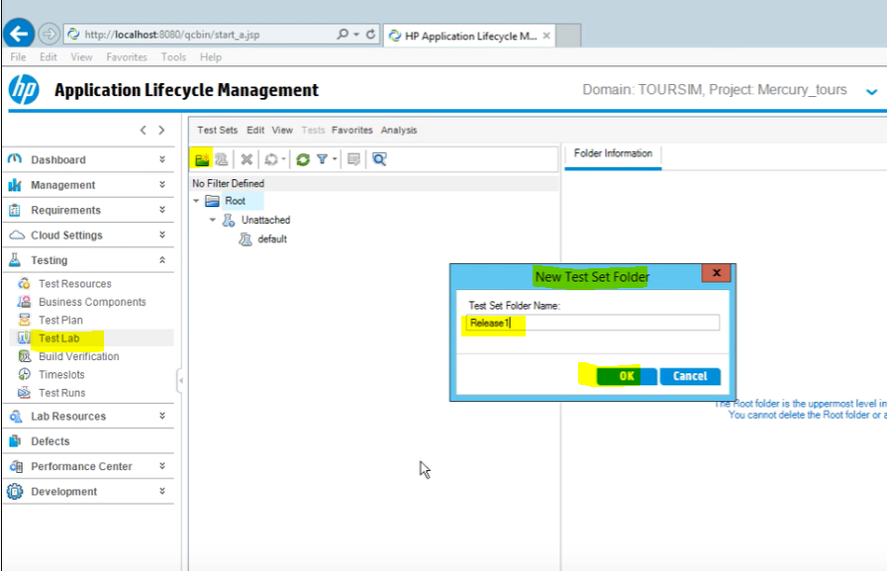

**You can also create child folders to organize better**

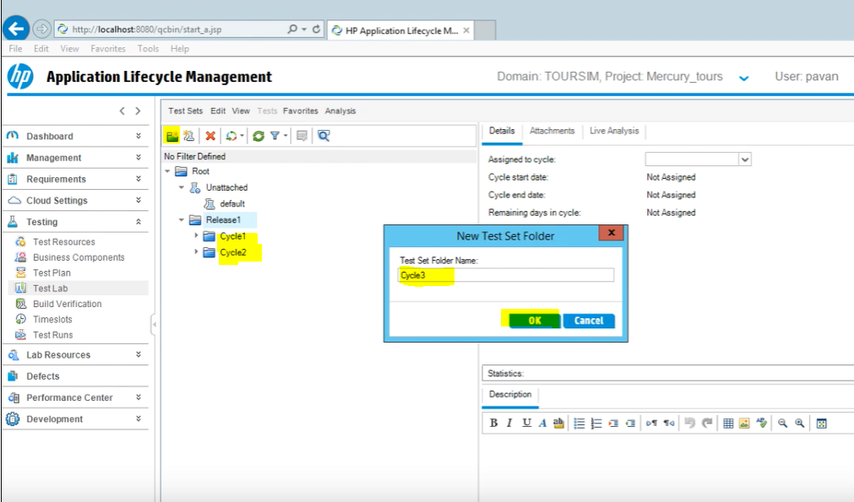

**Then in these folder we can create our TEST SETS**

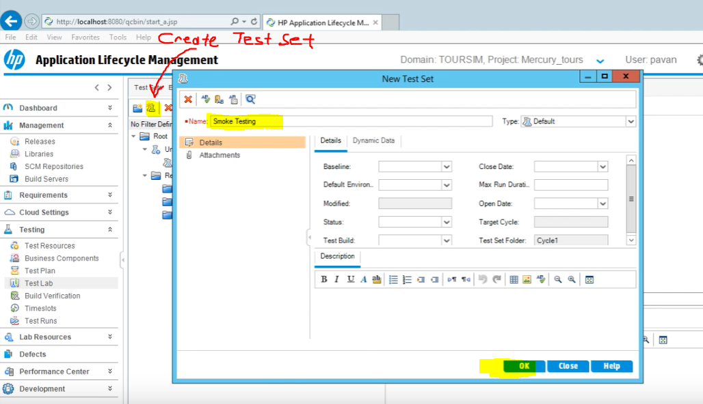

**After creating the test sets, we can assign the folder that including the test sets to a certain a cycle to be completed.**

**Only folder can be assigned so test sets should be in the folder you assign.**

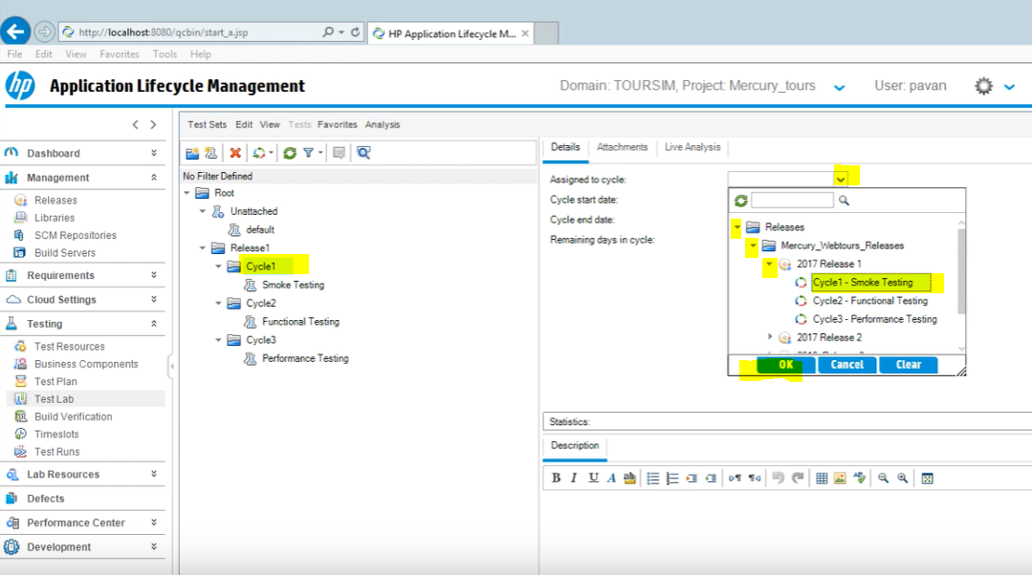

**In this example, we assigned Cycle1 test set folder to Actual Cycle 1 under Release 1**

**That means these test sets should be completed in the first release during cycle 1**

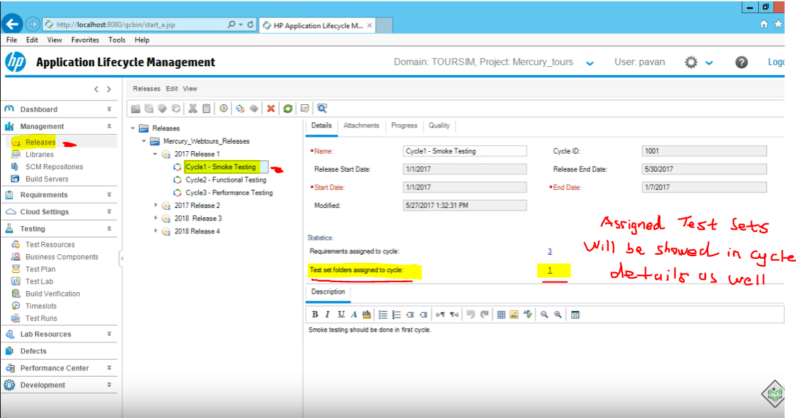

**We can also add test cases to Test Sets.**

**Go to Test Lab and Select the test set you want to add existing test cases.**

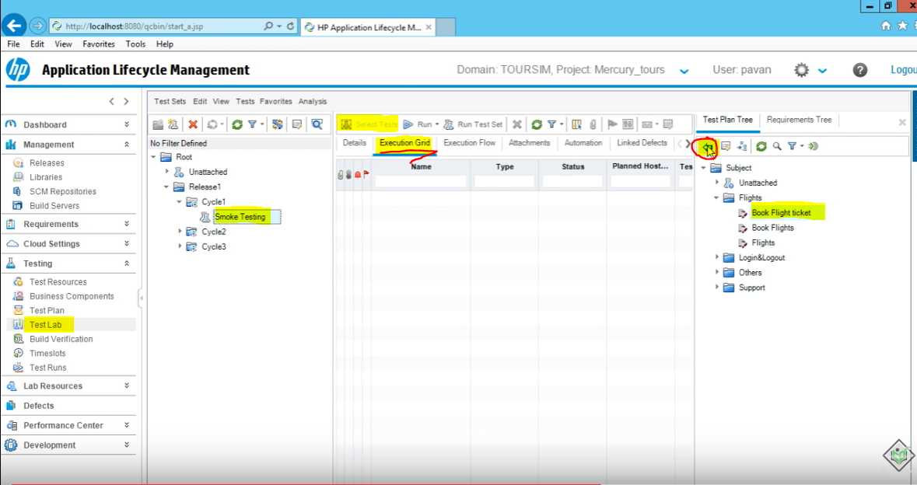

**Select Tests will be disabled first, you need to click on Execution Grid, then it’ll be enabled**